|  |  |  |
| --- | --- | --- |
| **LAB 321 Assignment** | **Type:** | **Long Assignment** |
| **Code:** | **J3.L.P0005** |
| **LOC:** | **300** |
| **Slot(s):** | **10** |

**Title:** My Blogs

**Background**

Google+ and FaceBook are most popular social media network. Do you know how to make a simple blog? Let try in this assignment

**Program Specifications**

Program a Blogs, detail functions of this website is described below

**Features:**

This website contains 03 (six) main functions

* Function 1: Home page ( see figure 01)
  + Display information of the most recent blog
  + On the right side of page is the lists of blog categories, users are allow to view all blogs of each categories.
* Function 2: Footer of home page ( see PIC 02)
  + Display the title blogs of 3 most recent blog.
* Function 3: Contact page ( see PIC 03)

Note: All data must be load from database, not hard code.

***Expectation of User interface:***

Pic 01: Home Page ( TOP)

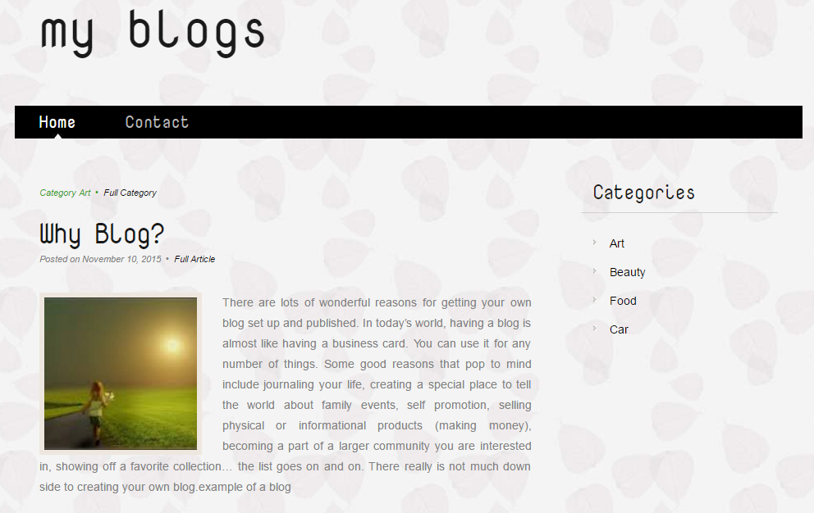

'Nova Mono', cursive

PIC 02: Footer of Home Page

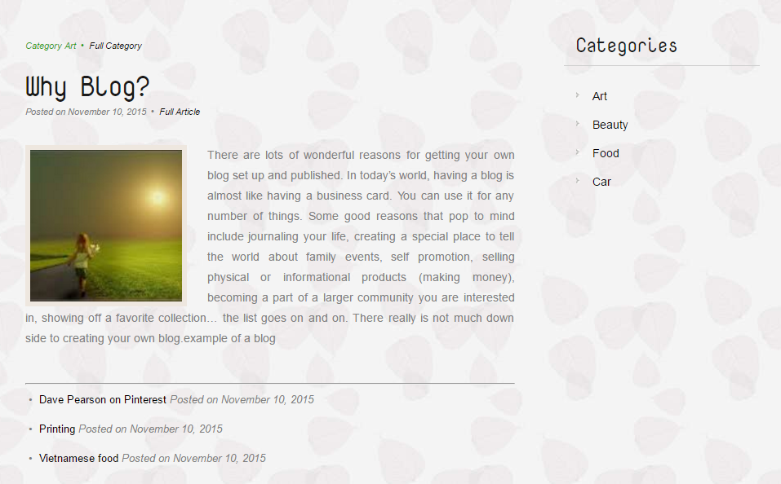

All blog category here

Pic 03: Contact Page

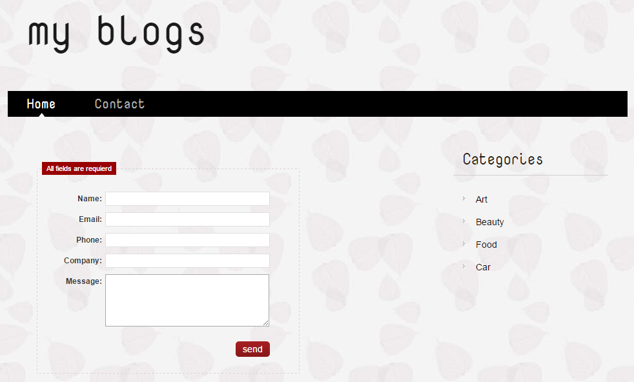

Save it on database

**Guidelines**

* Step 1 : Create prototype
* Step 2 : Design database base on created prototype
* Step 3 : Code & Test